ASSIGNMENT 1

Himanshu goyal

**Question 1)**

There is a database containing that the students enrolled the courses taught by different instructors. There are three entity sets: (1) student (attribute: student id, class, student name, student gender, student date of birth), (2) course (attribute: course number, course name, number of credit), and (3) instructor (attribute: instructor id, instructor name, instructor title). The students can “enroll” the courses. Each student can enroll many courses. Each course can be enrolled by many students. The instructor can “teach” certain course(s). An instructor can teach many courses, but one course can only have one instructor. Please draw an ER diagram reflecting student, course, and instructor, respectively. Note: You can draw the diagram using tools or you can draw it and photo it. Both are fine. There might be multiple rules to draw an ER diagram. You can choose either of them. (40% in this assignment)

**Answer:**

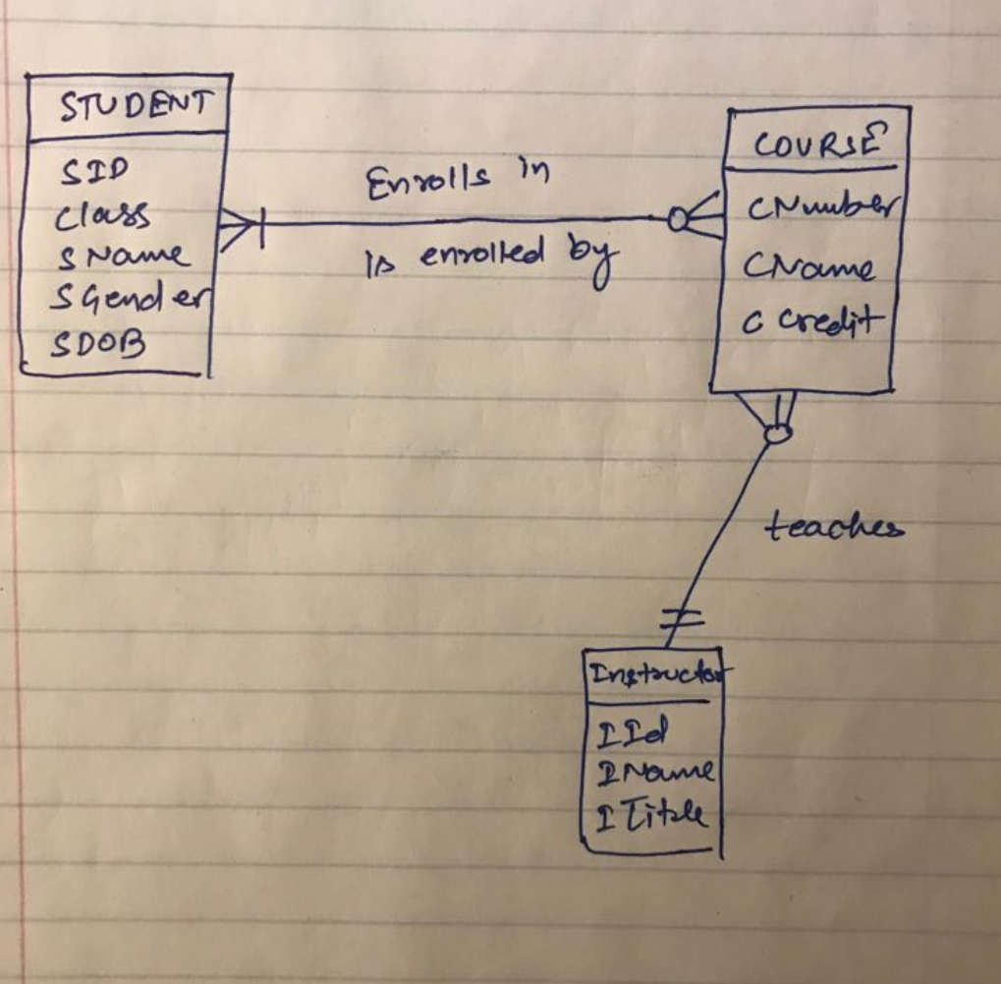

**Question 2:**

1. Suppose that there are three relationships in a database:

Student relationship: S(SNO, SNAME, AGE, GENDER, DEPT)

Enroll relationship: SC(SNO, CNO, GRADE)

Course relationship: C(CNO, CNAME)

Here, the abbreviation and their full name correspond as:

|  |  |  |  |
| --- | --- | --- | --- |
| SNO | Student Id number | DEPT | Student department |
| SNAME | Student name | CNO | Course number |
| AGE | Student age | GRADE | Course grade for certain student |
| GENDER | Student gender | CNAME | Course name |

Please use relational algebra to describe the following queries. The 8th question’s answer is provided as an example. (60% in this assignment, 6% for each)

**Answer:**

Here is the dataset that I had loaded.

-- this is an example

group: nameOfTheNewGroup

S = { SNO:string, SNAME:string,AGE:number, GENDER:string, DEPT:string

S1, Kriss, 25, M, Analytics

S2, Justin, 23, M, DataScience

S3, Sree, 20, M, Math

S4, Lara,26, F, Stata

S5, Jenn, 22, F, Analytics}

SC= {SNO:string, CNO:string, GRADE:number

S1, C1, 80

S1, C3, 90

S2, C4, 90

S2, C1, 60

S3, C1, 70

S3, C2, 60

S3, C3, 80

S3, C4, 90

S4, C4, 50

S5, C2, 90

S5, C3, 60}

C = {CNO:string, CNAME:string

C1, Statatic

C2, Network

C3, 'data Vis'

C4, 'SQL and NoSQL'}

* Query the id number and the grade of the students who enrolled the course whose course number is C2.

π SNO, GRADE (σ CNO = 'C2' (SC))

* Query the id number and the name of the students who enrolled the course whose course number is C2.

π SNO, SNAME (σ CNO = 'C2' (SC) ⨝ (S))

* Query the id number and the name of the students who enrolled the course whose name is “SQL and NoSQL”.

π SNO, SNAME ((S) ⨝ ( σ CNAME = 'SQL and NoSQL' (C) ⨝ (SC)))

* Query the id number of the student who enrolled C2 or C4 course.

π SNO (σ CNO = 'C2' ∨ CNO = 'C4' (SC))

* Query the id number of the students who at least enrolled C2 and C4 courses. (Hint: You might want to refer to Exercise 2 Question 6 before finish this query)

π 1 (σ  1= 4 ∧ 2= ‘C2’ ∧ 5= ‘C4’  (SC ⨝ SC))

* Query the id number (here it means student’s id number), name, and age of the students who did not enroll C2 course. (Hint: Please use “-”, i.e. difference, in relational algebra to describe this query)

(π SNO, SNAME, AGE (S)) - ( π SNO, SNAME, AGE ( σ CNO = 'C2' (SC) ⨝ (S)))

* Query the names of the students who enrolled all of the courses.

π SNO, SNAME(S ⨝ SC) %[1] π CNO(SC)

* Query all of the id number and name of the students who enrolled the courses that were also enrolled by student whose id number is S3.

π SNO,SNAME,CNO (S|×|SC)% π CNO (σ SNO='S3‘ (SC))

* Query all of the id number and name of the male students whose grade is 80-90 (including 80 and 90) in the course of “SQL and NoSQL”.

π SNO, SNAME(σ GENDER = ‘MALE’ ∧ CNAME = ‘SQL and NoSQL’ ∧ GRADE>=80 ∧ GRADE<=90 (S ⨝ SC ⨝C))

* Query all of the id number, name, gender, and department of the students who did not enrolled “Topics in Informatics” course.

(π  SNO, SNAME, GENDER, DEPT (S)) - (π SNO, SNAME, GENDER, DEPT ((σ CNAME = 'Topics in Informatics' (C) ⨝ SC) ⨝ (S)))